DRIVE ONE 4 ESPERANZA
Esperanza and Fairway Ford in Yorba Linda have teamed up to raise money for Esperanza High School. Come test drive a car on Saturday, April 24th from 8:30-4:30. Each test drive and completed survey raises $20 for EHS!*
& 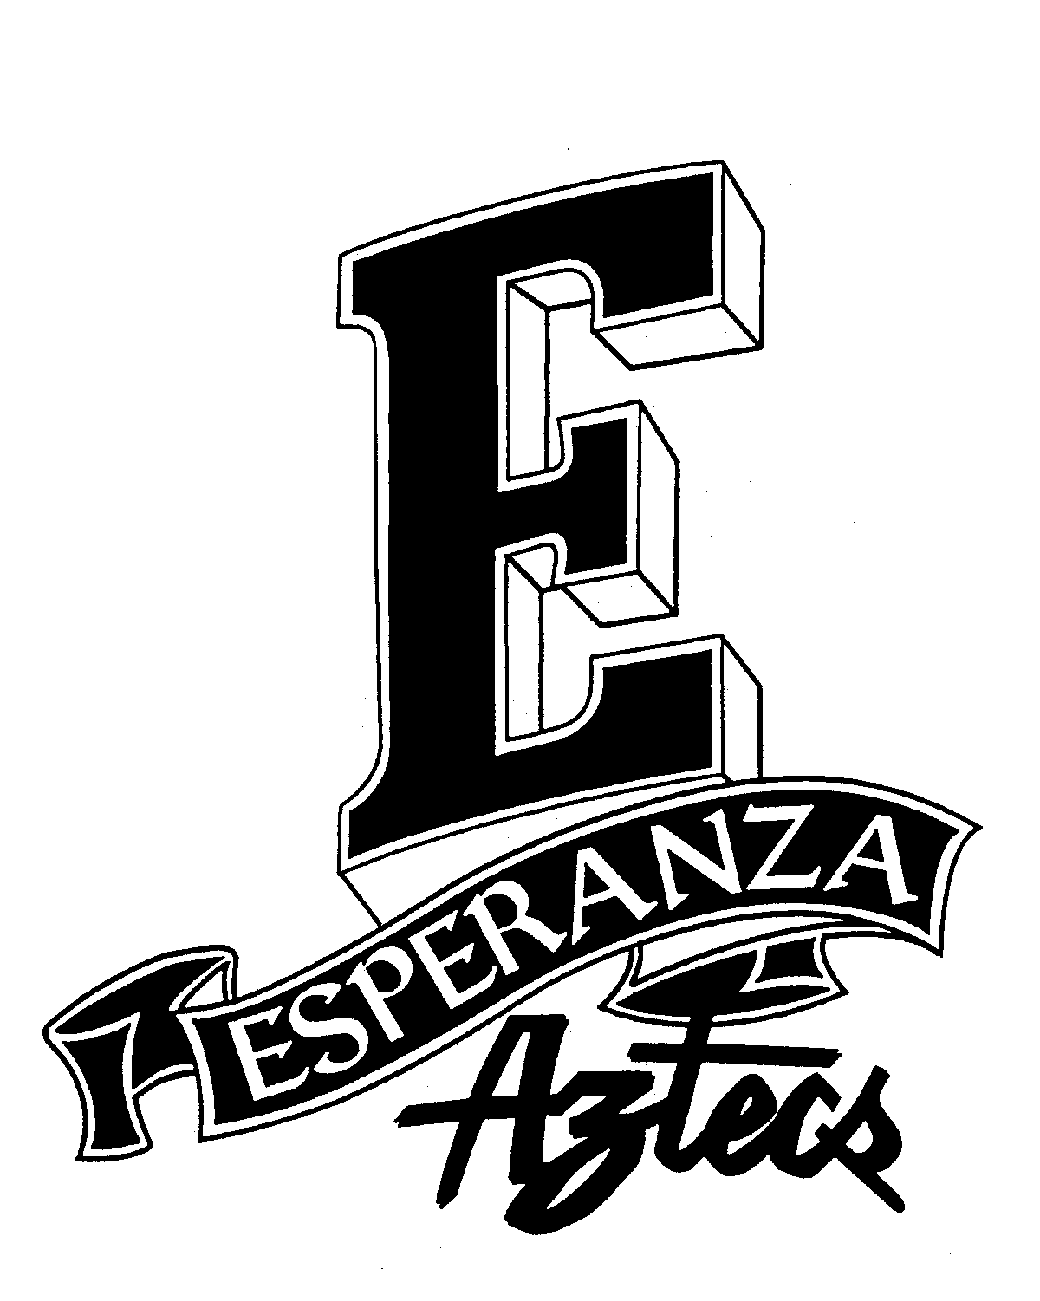

IT IS FREE , just come drive a car!*
(Must be at least18 years of age)

Event Details:
Where: Esperanza High School Parking Lot
When: Sat. April 24th, 2010 from 8:30- 4:30pm
Why: Each test drive and completed survey earns $20 towards EHS.
How: It is FREE, must be over 18. Fill out a
questionnaire, test drive a FORD, and complete a survey.
Who Benefits: EHS student body, sports, activities and clubs will receive a percentage of the amount raised.

*Refreshments and EHS spirit wear will be available for purchase*

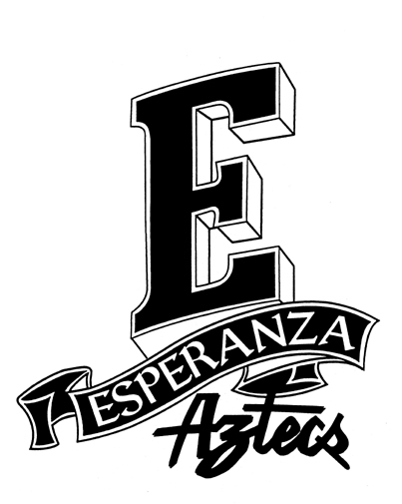
*One per family NOT A PYLUSD DISTRIST ENDORSED EVENT

